GOVT.DEGREE COLLEGE: RAJAM:SRIKAKULAM DIST.
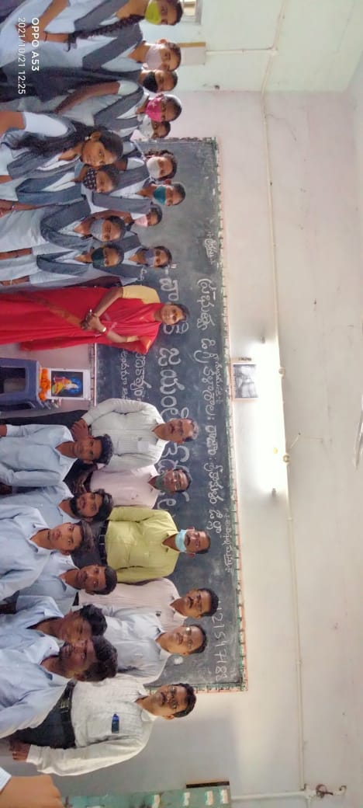
IQAC ACTIVITIES
1.Conducted Telugu Department VALMIKI JAYANTHI on 20-10-2021.
Chief Guest: Dr.swapnaHaindavee,Principal,GDCRajam.

2.Conducted Commerce DepartmentPOLICE COMMEMORATION DAY on 21-10-2021.
Chief Guest: Dr.swapna Haindavee,Principal,GDCRajam.
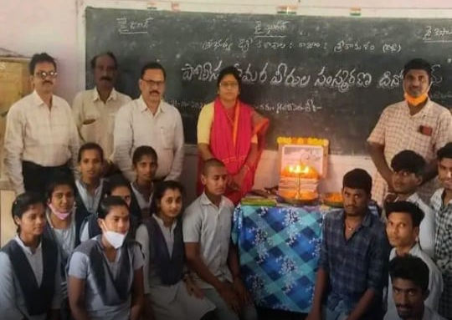

3.Conducted SWACHCHA BHARATH at Campus on 23-10-2021

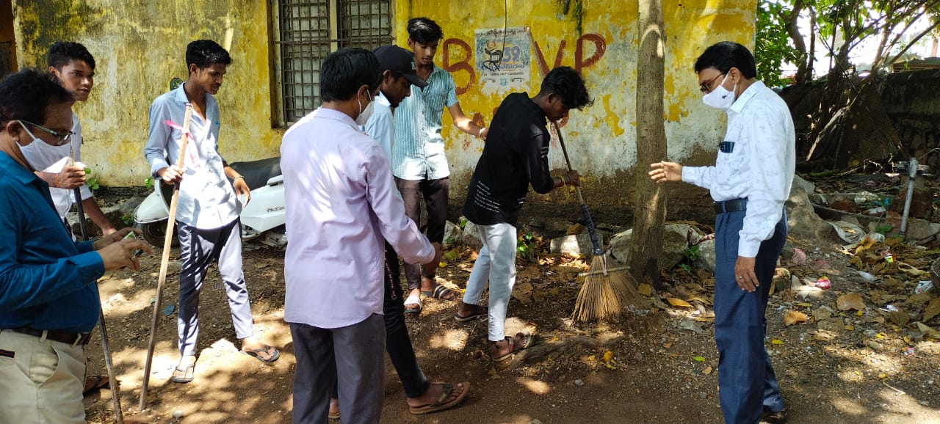
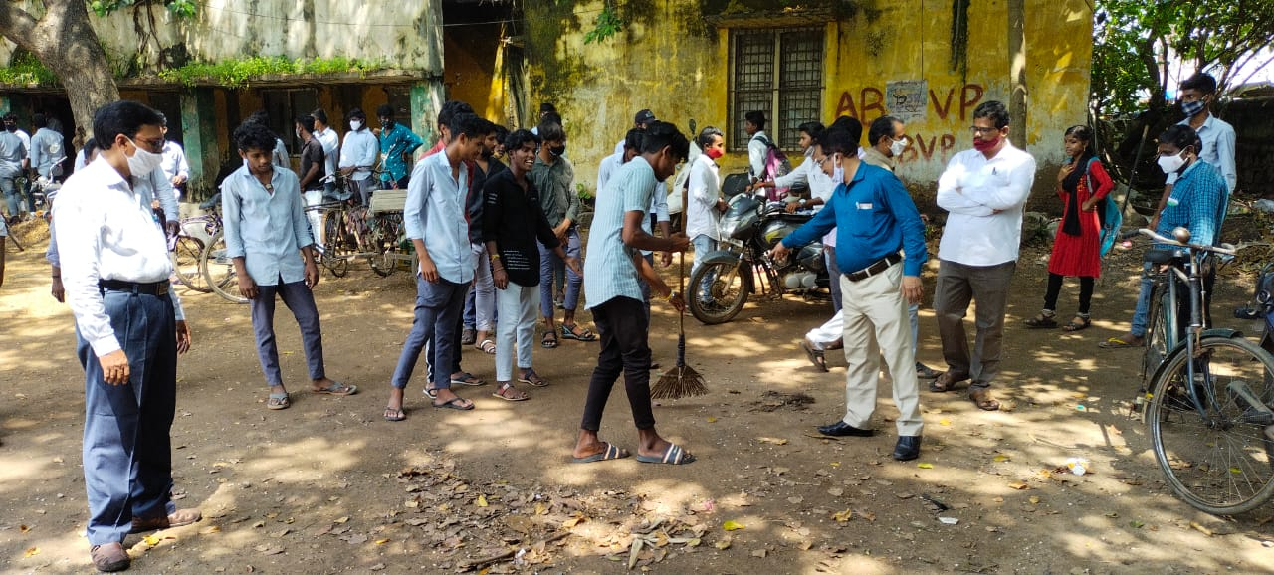
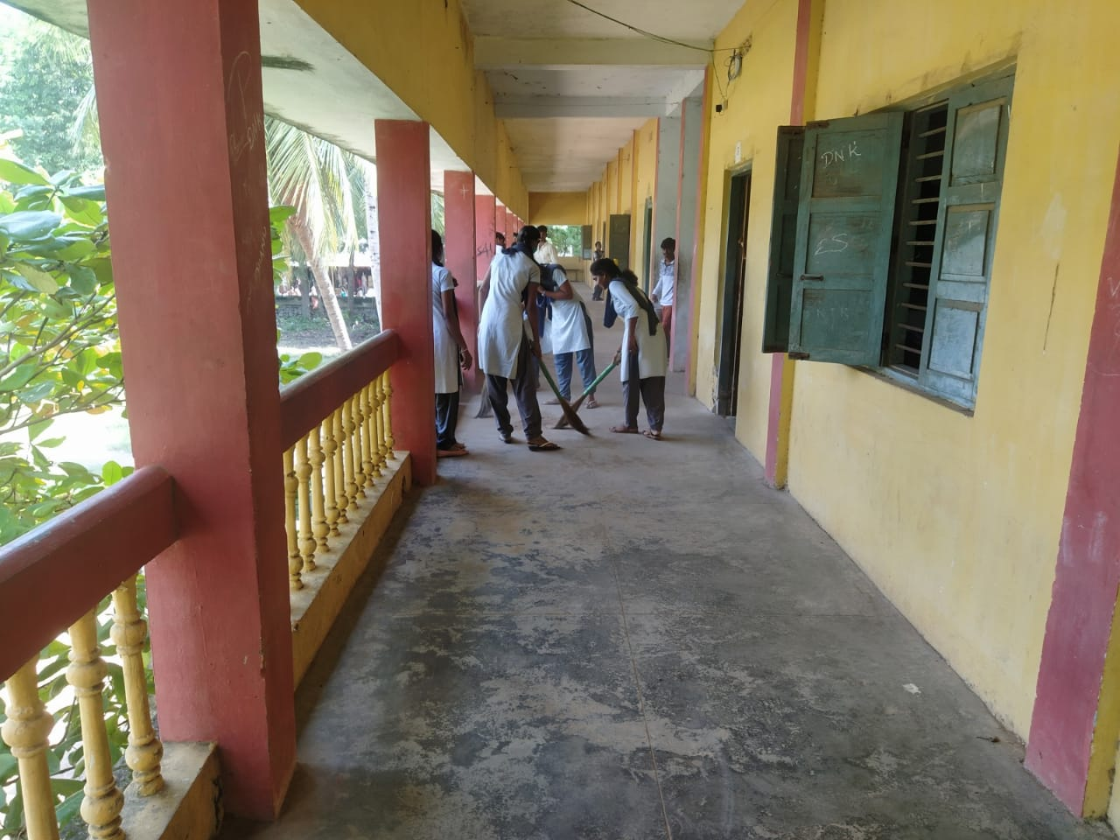

4.Conducted Political Science Department UNO DAY on 24-10-2021.
Chief Guest: Dr.Swapna Haindavee,Principal,GDCRajam.
5.Conducted SRI GURU SAMARCHANA DINOTSAVAM By Students on 27-10-2021.
Chief Guest: Dr.Swapna Haindavee,Principal,GDCRajam.
Guest:Sri M.Kameswara rao,Principal,G.J.College,Rajam

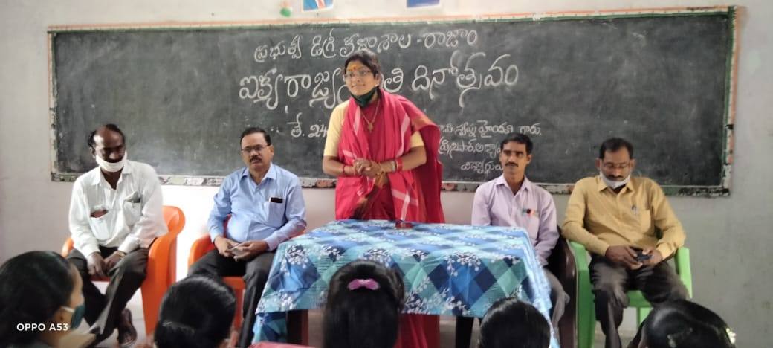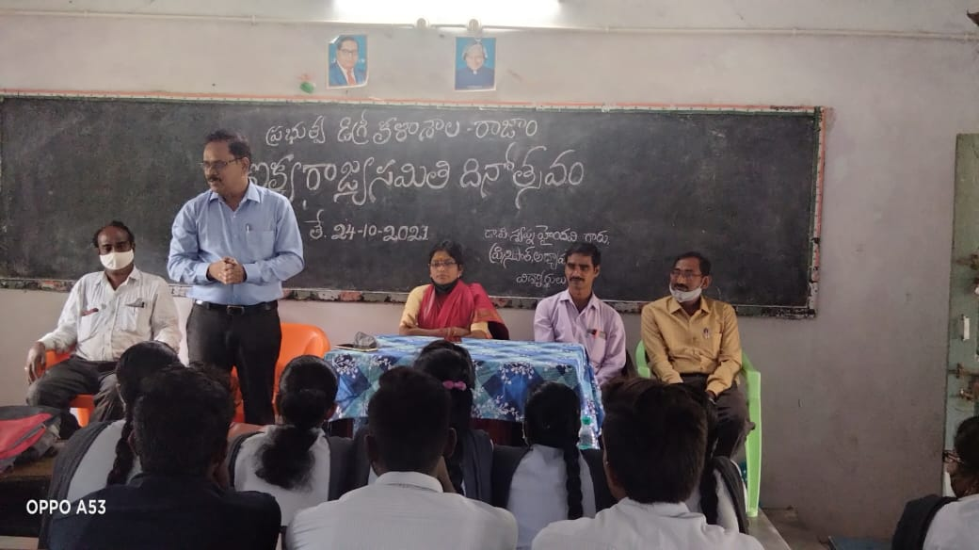

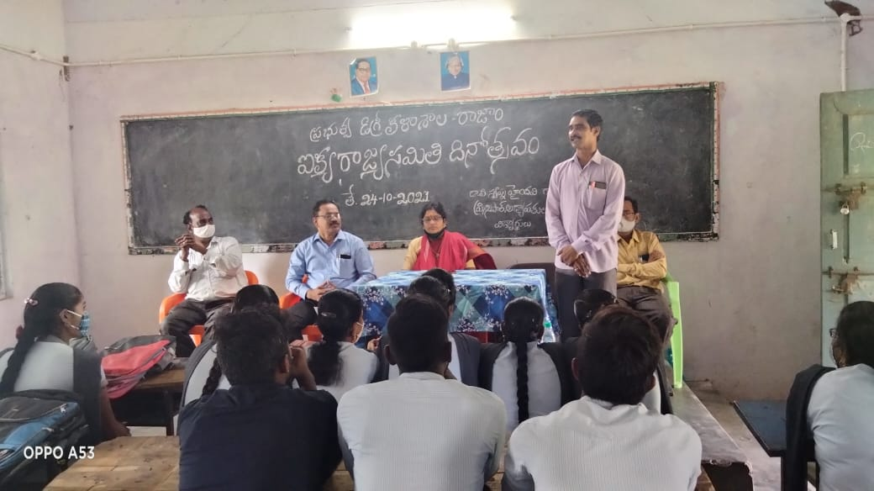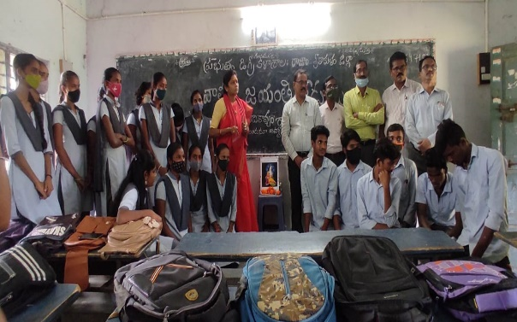

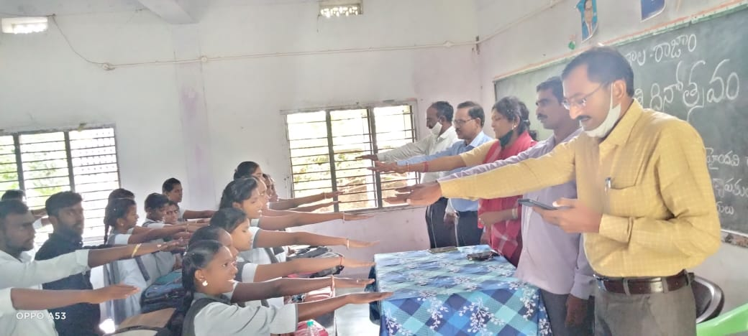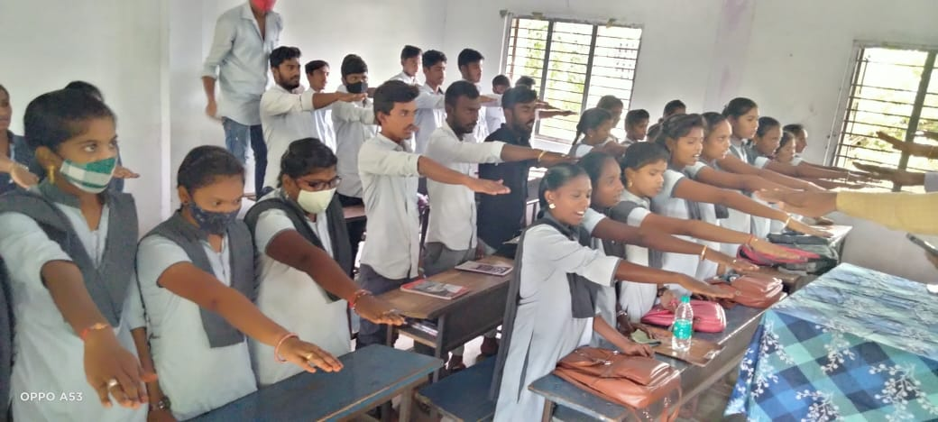

6.Conducted Woman Empowerment Cell SISTER NIVEDITA JAYANTHI on 28-10-2021.
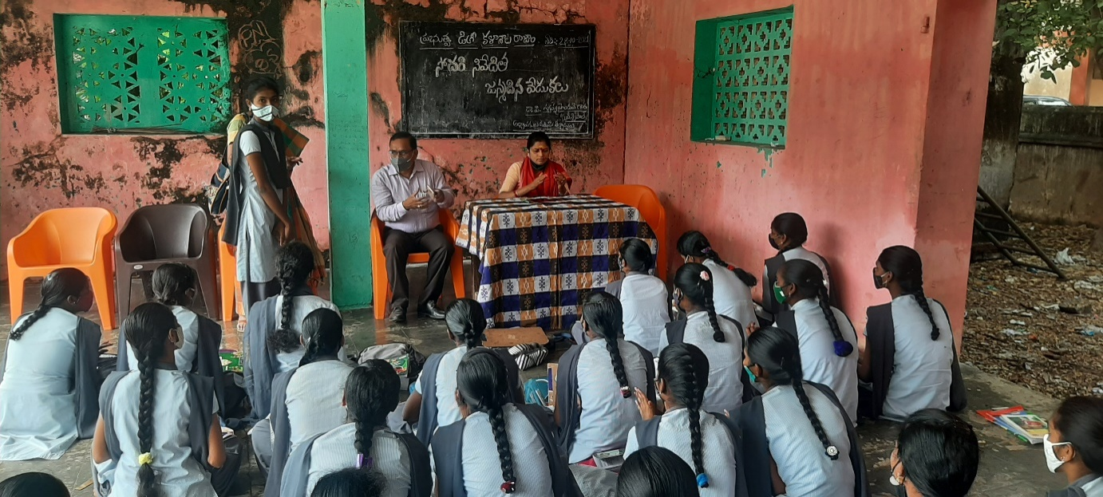
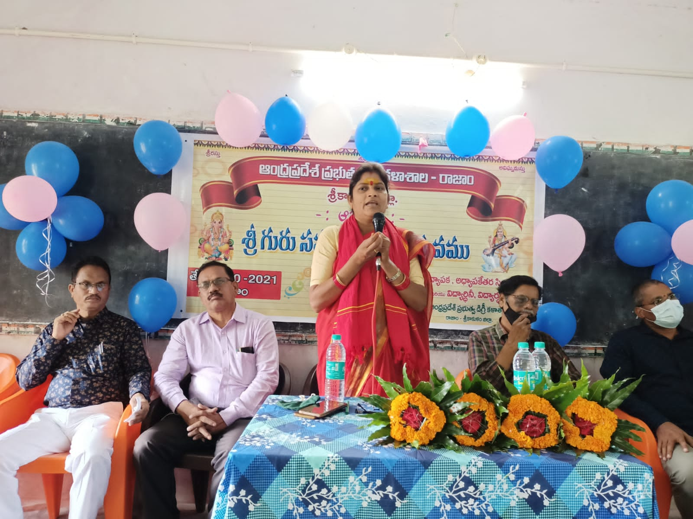
Chief Guest: Dr.Swapna Haindavee,Principal,GDCRajam.
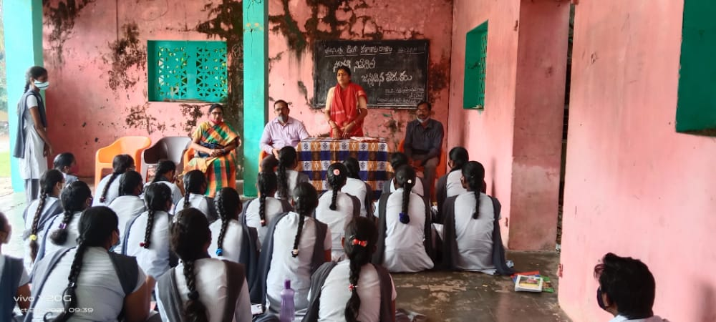

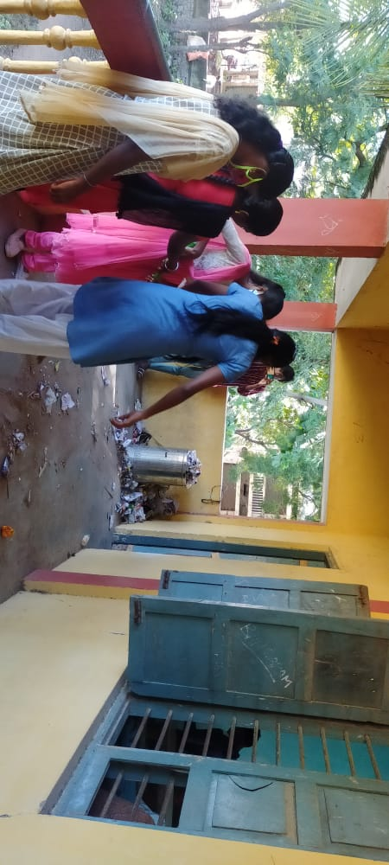
7.Conducted SWACHCHA BHARATH at Campus on 30-10-2021
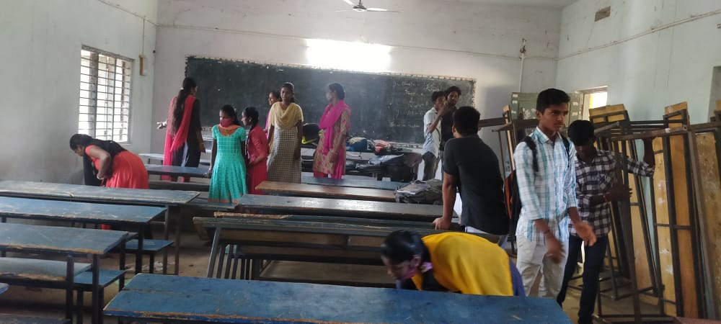
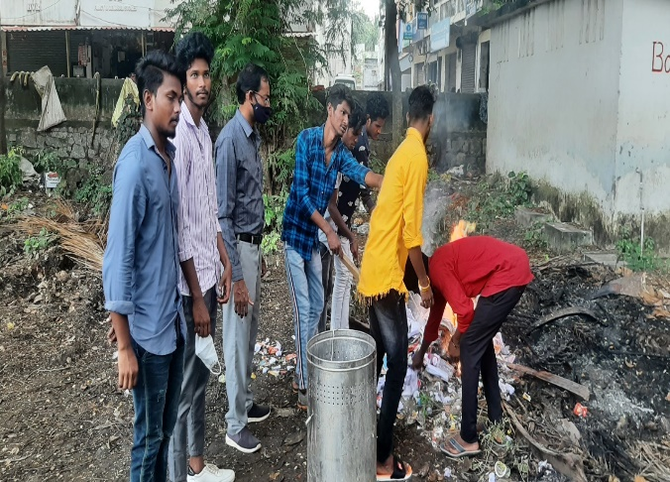
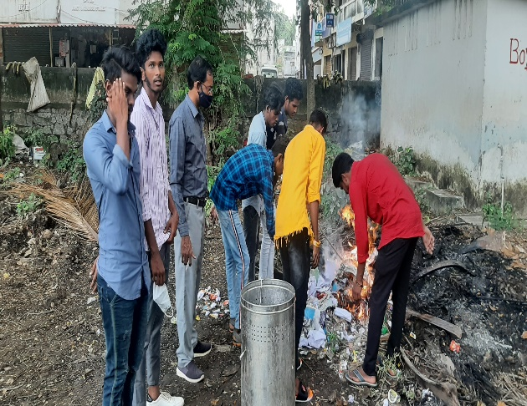
8.Conducted ANDHRA PRADESH STATE FORMATION DAY By POLITICAL SCIENCE DEPARTMENT on 01-11-2021.
Chief Guest: Dr.P.Surya Rao,Vice - Principal,GDCRajam.
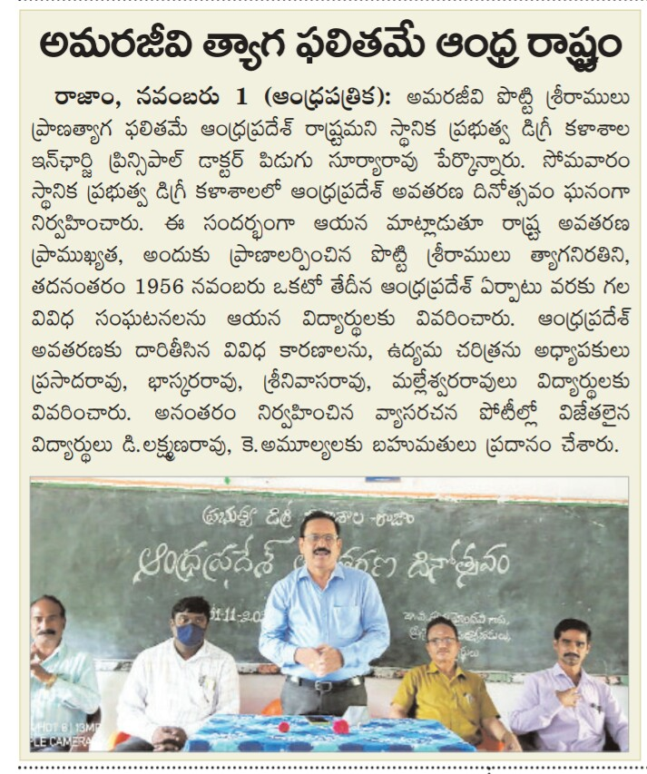
9.Conducted Commerce Department International Accounting Day on 10-11-2021.
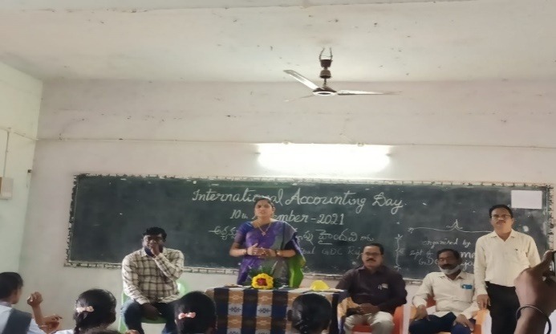
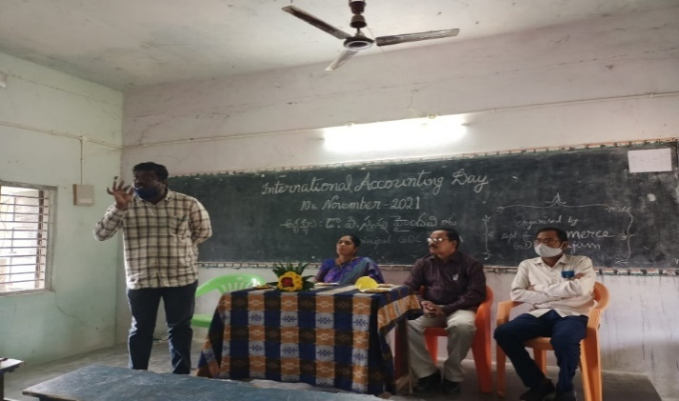
Chief Guest: Dr.P.Swapna Haindavee,Principal,GDCRajam.

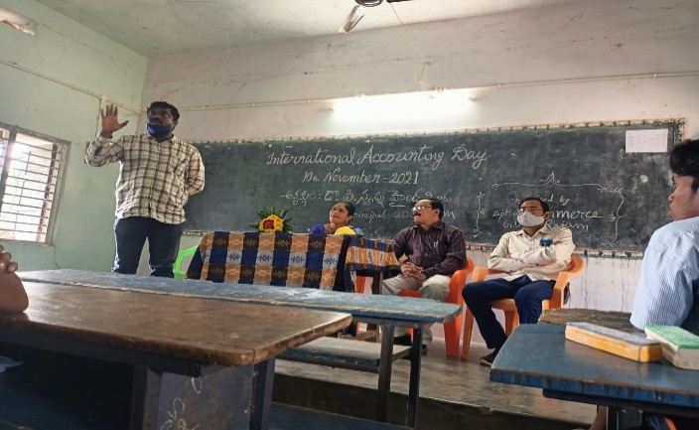
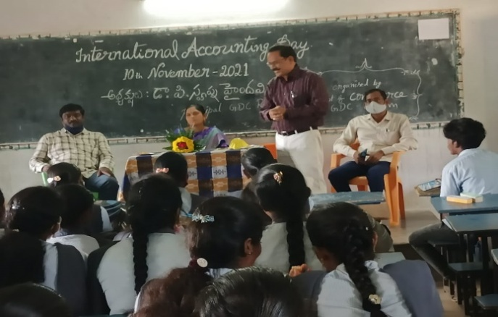

10.Conducted NATIONAL LIBRARY WEEK CELEBRATIONS By COLLEGE on 19-11-2021.
Chief Guest: Dr.P.Swapna Haindavee,Principal,GDCRajam.
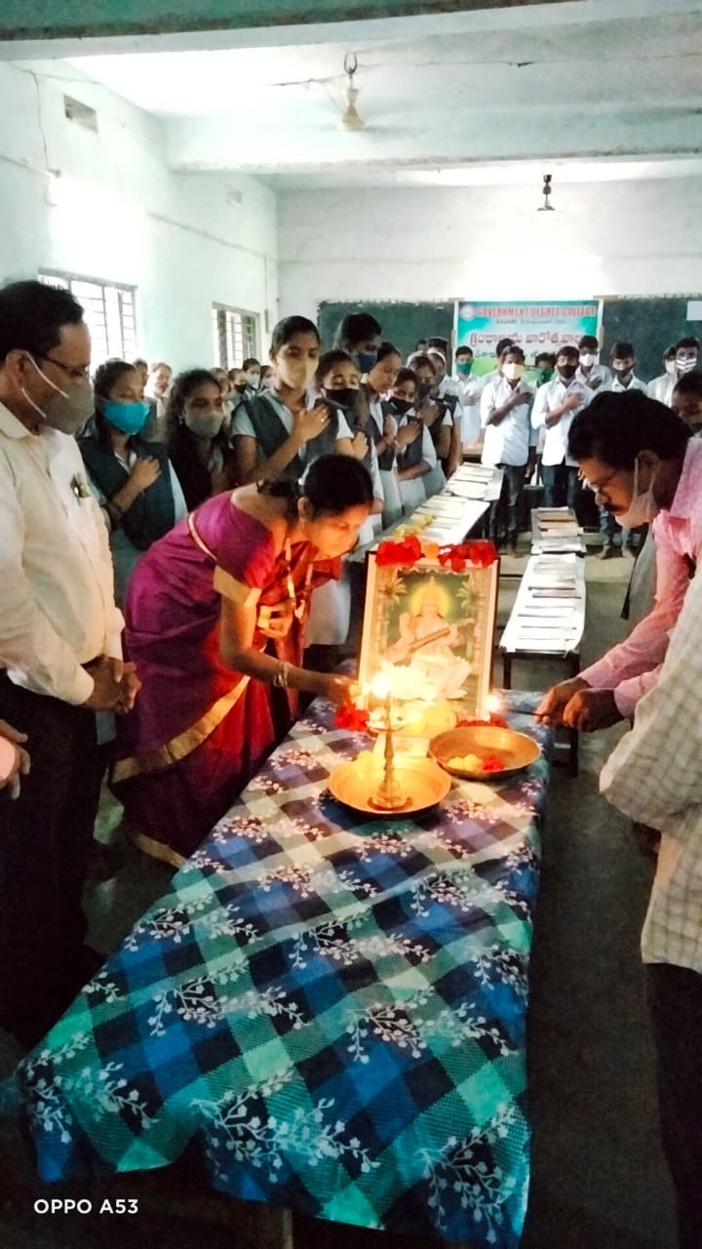
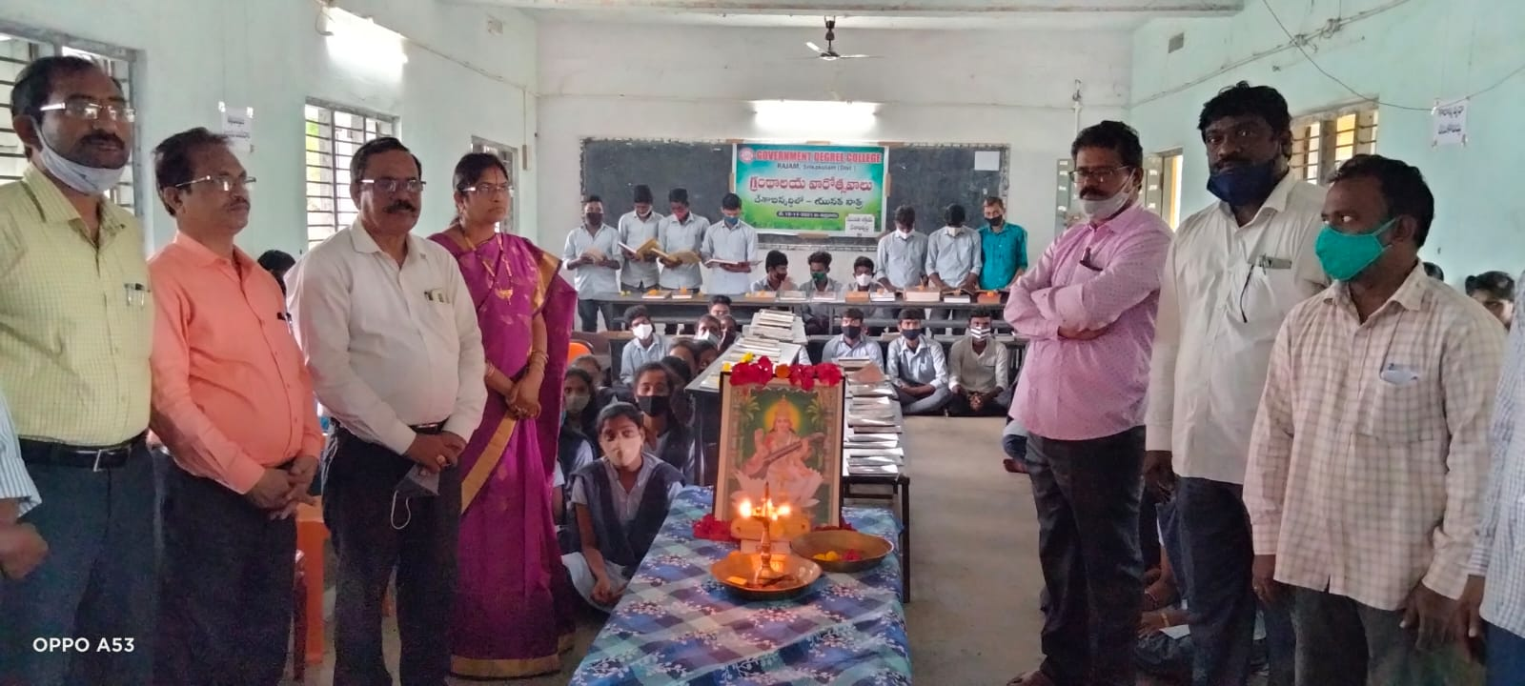

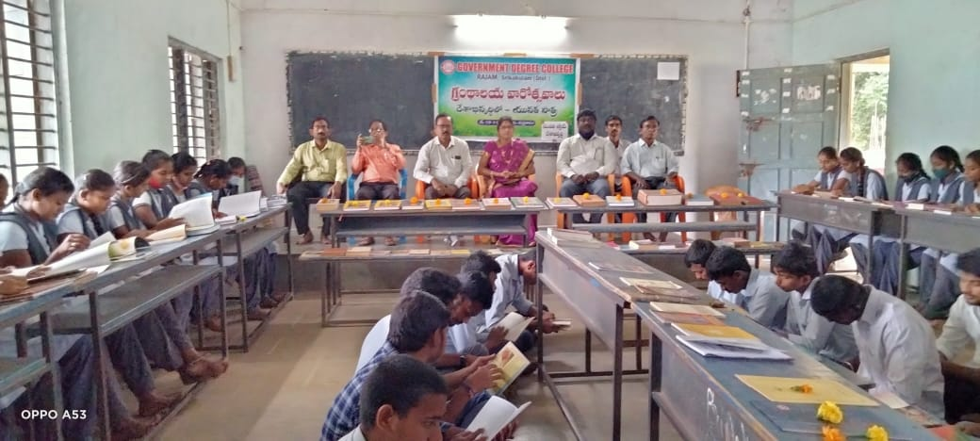
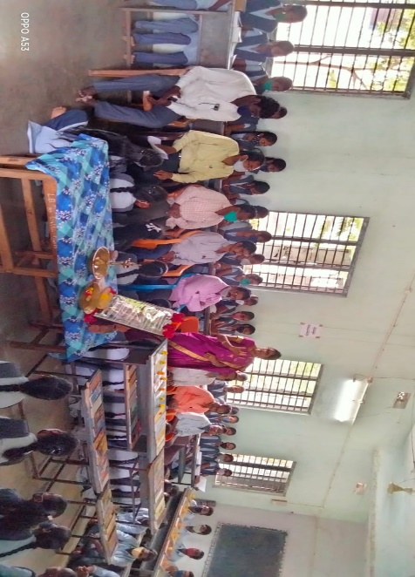
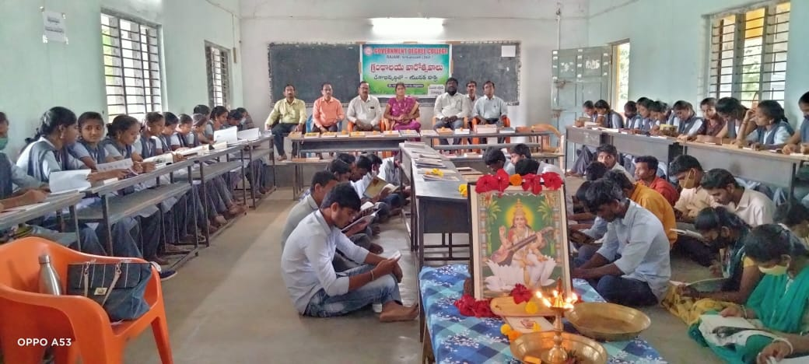

11.Conducted VOTER ENROLLMENT AWARENESS PROGRAMME By COLLEGE on 20-11-2021.
Chief Guest: Dr.Swapna Haindavee,Principal,GDCRajam
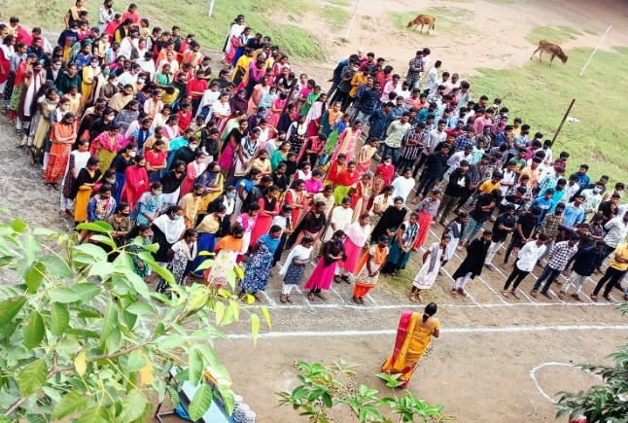
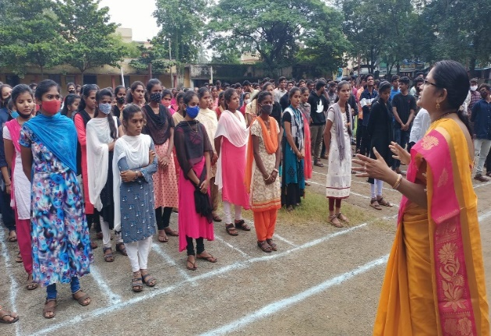
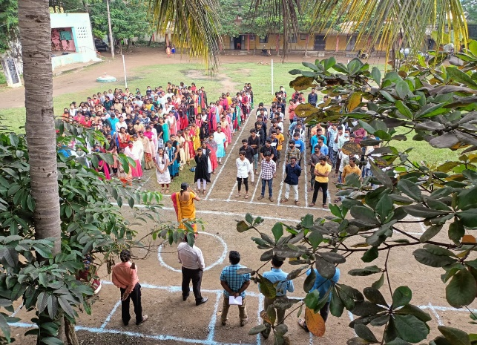
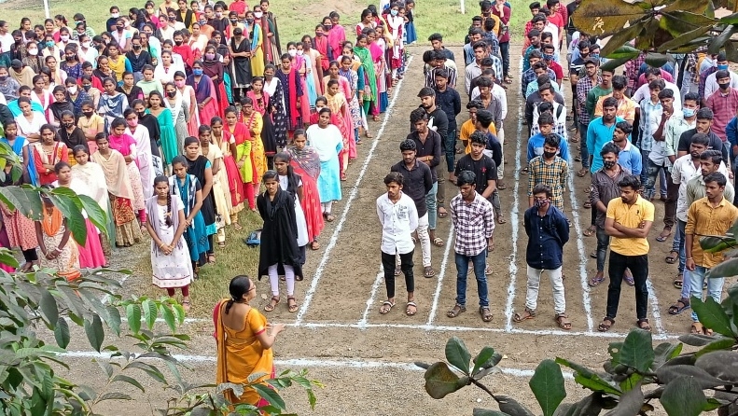
12.Conducted Vana Mahotsavam By Collegeon 22-11-2021
Chief Guest: Dr.P.Swapna Haindavee,Principal,GDCRajam
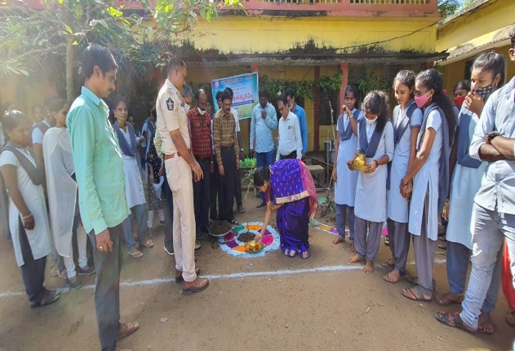
Chief Guest: Sri.S.Srinivasa Rao,Circle Inspector,Rajam
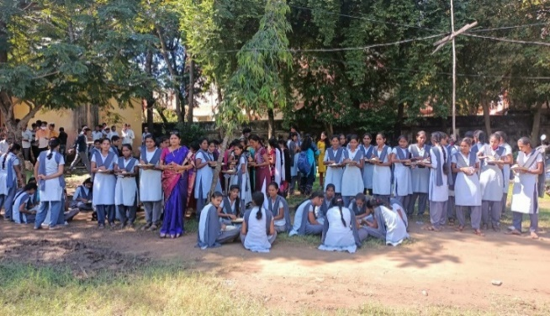
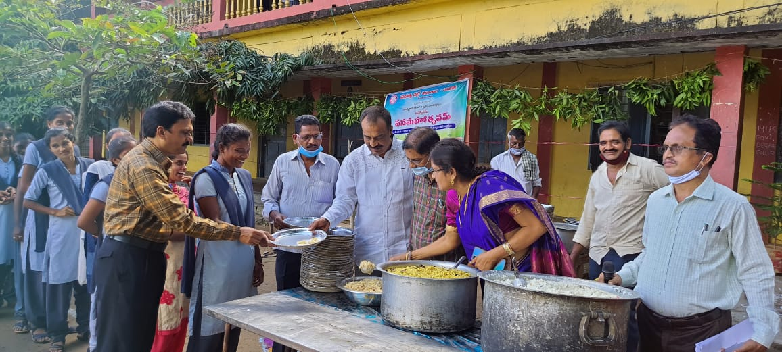
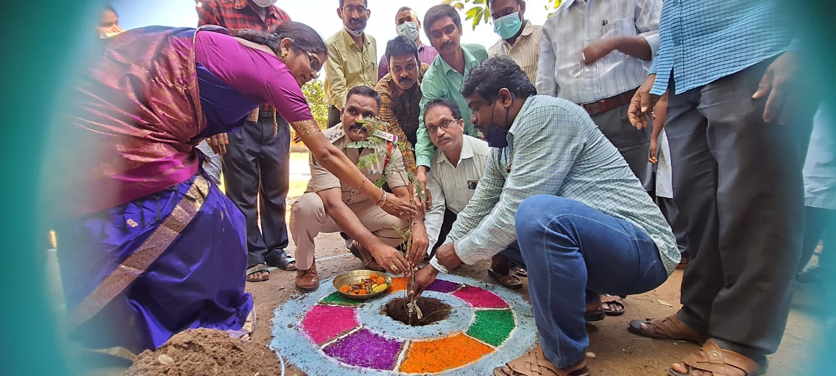

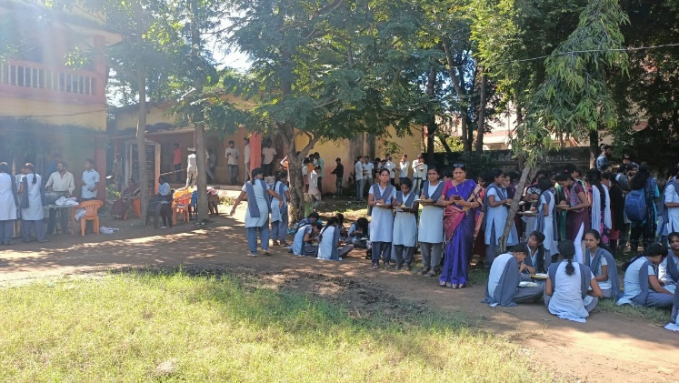
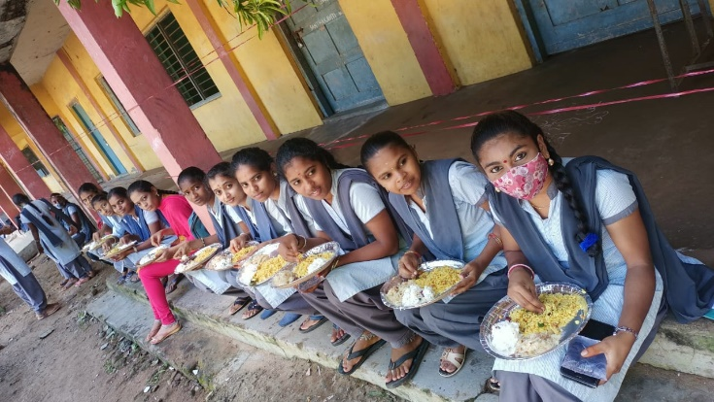
13.Conducted Indian ConstitutionalDayBy POLITICAL SCIENCE DEPARTMENT on 26-11-2021.
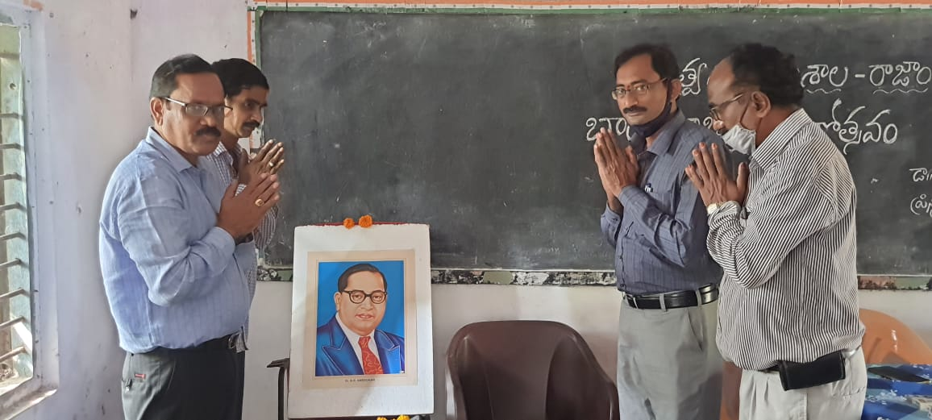
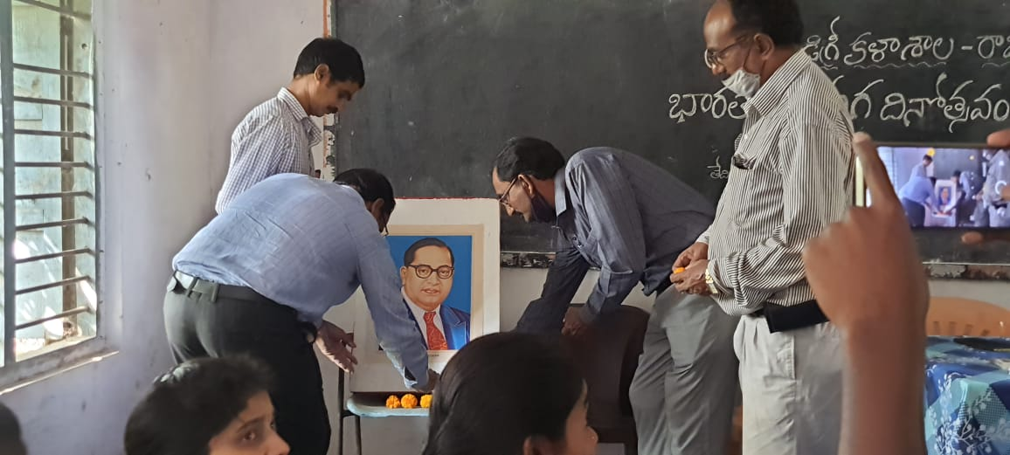
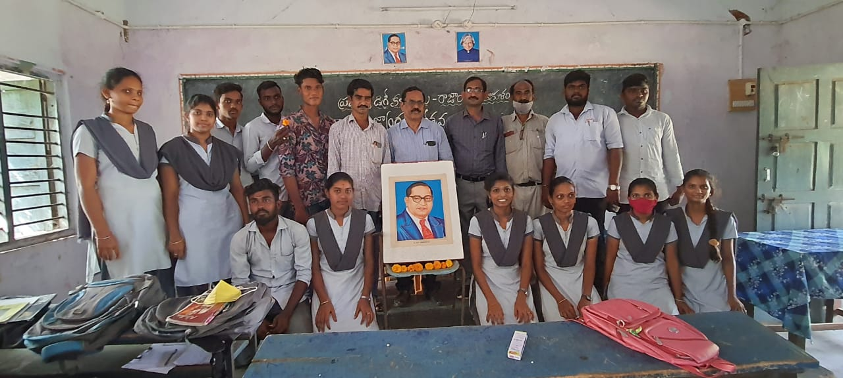
Chief Guest: Dr.P.Surya Rao, Vice - Principal,GDCRajam.
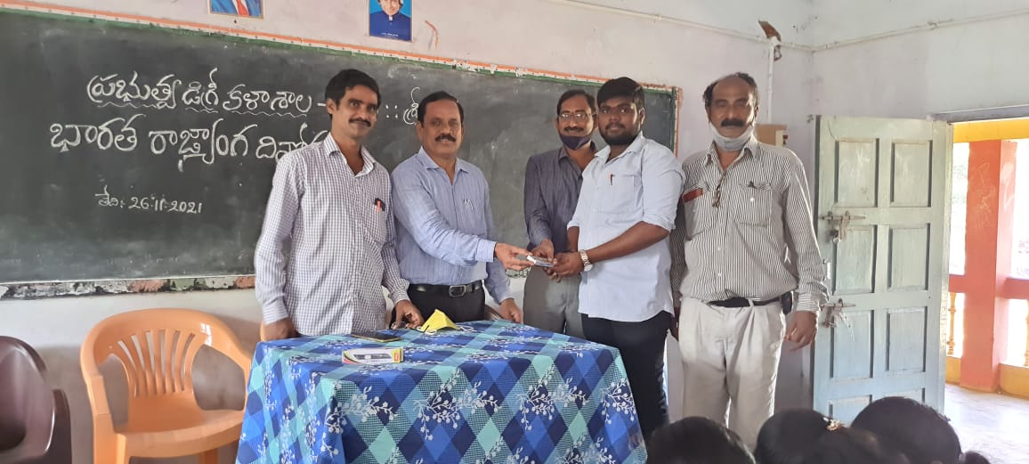
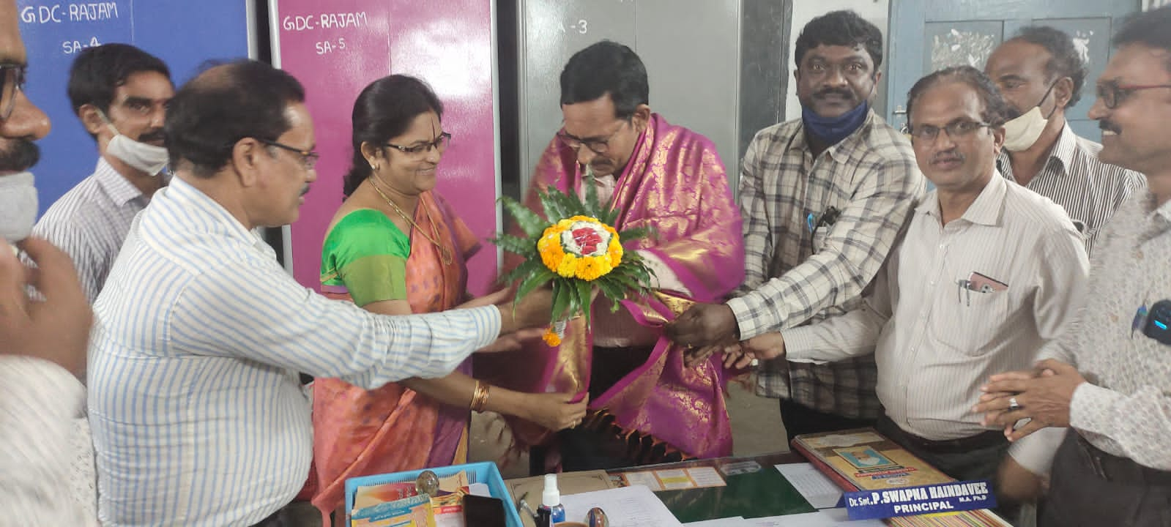
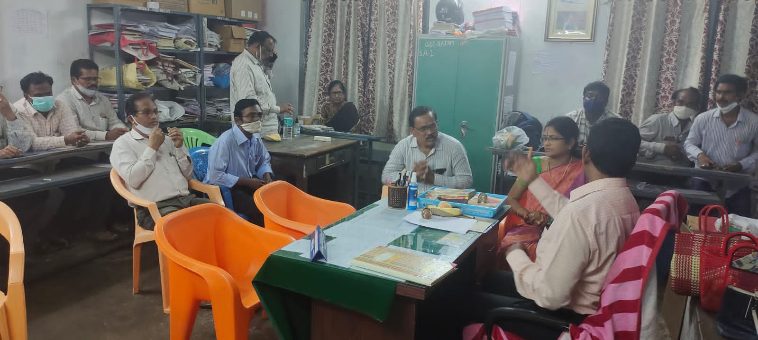
14.RJD OF CCE VISIT ON 07-12-2021

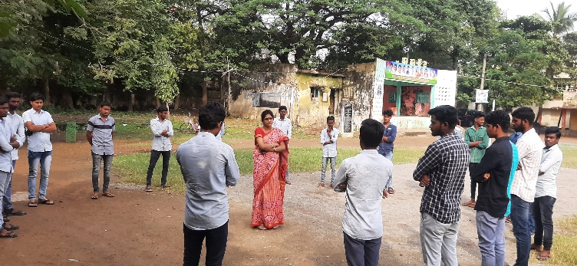
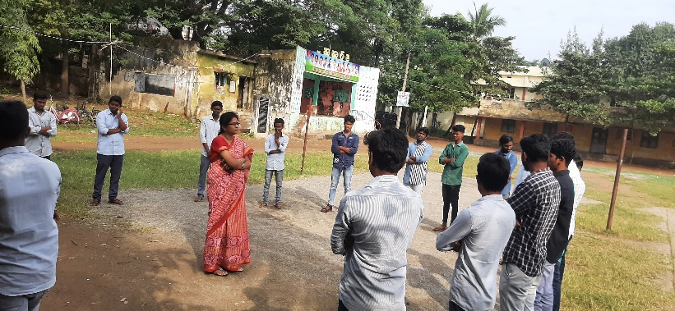
15.Dr.P.Swapna Haindavee,Principal,GDCRajam INTERACTION WITH STUDENT LEADERS on 10-12-2021
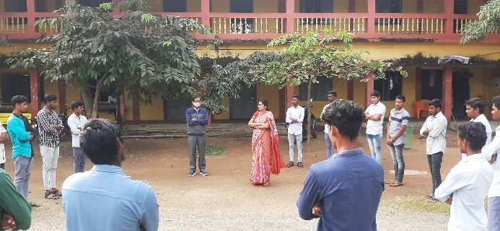
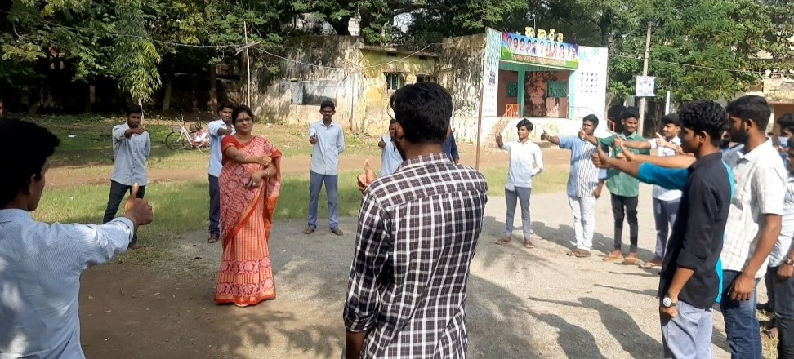
16.Conducted HUMANRIGHTS DAY By POLITICAL SCIENCE DEPARTMENT on 10-12-2021
Chief Guest: Dr.P.Swapna Haindavee,Principal,GDCRajam
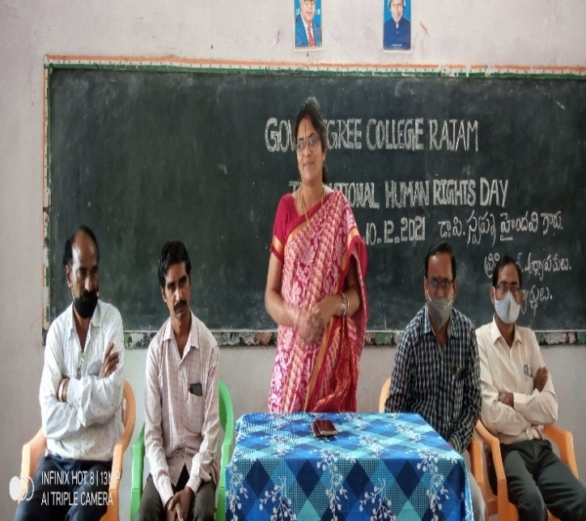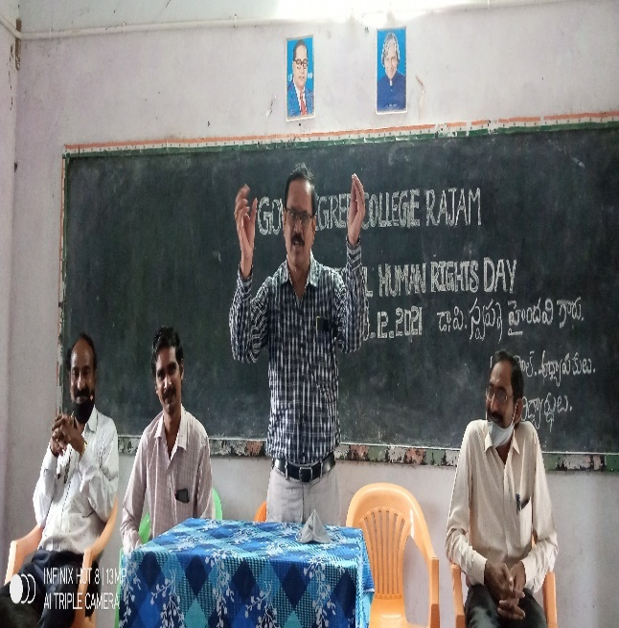
17.Conducted GEETA JAYANTHI By By College on 14-12-2021
Chief Guest: Dr.P.Swapna Haindavee,Principal,GDCRajam
Chief Guest: Sri.P.Srinivasa Rao,Lawyer,Rajam
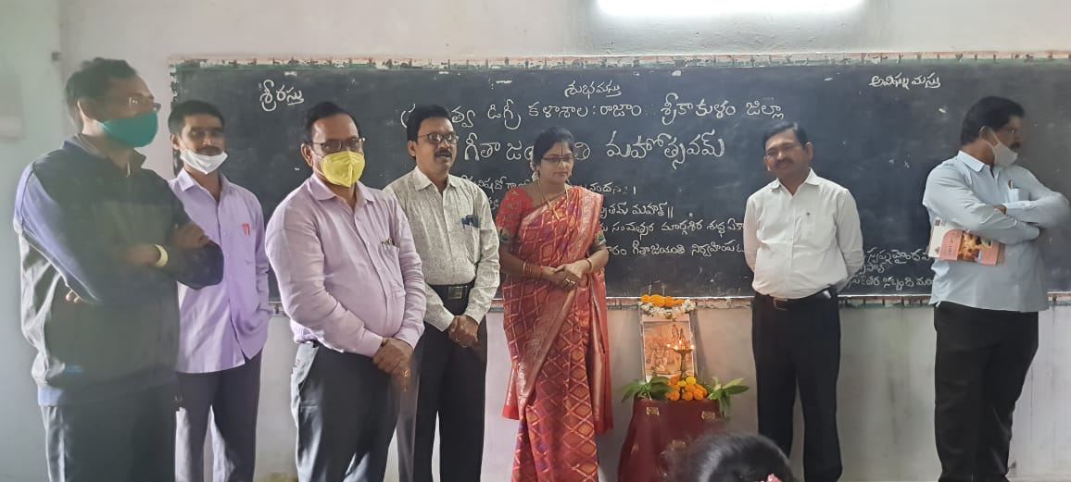
18.Conducted Legal Awareness Programme By By College on 18-12-2021
Chief Guest: Dr.P.Swapna Haindavee,Principal,GDCRajam
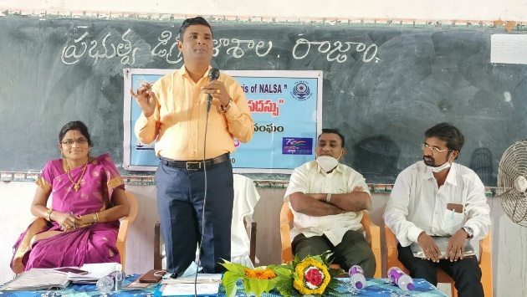
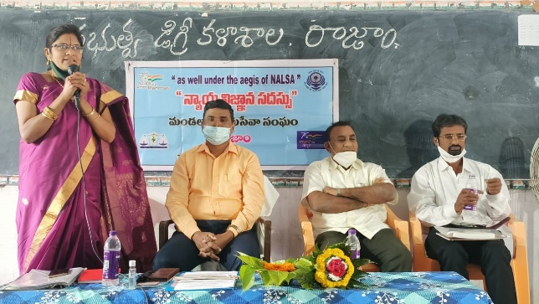
Chief Guest:Sri.P.BABU,Junior Civil Judge,Rajam

19.Conducted NATIONAL MATHEMATICS DAY As Srinivasa Ramanujan Jayanthi By Maths Department on 22-12-2021
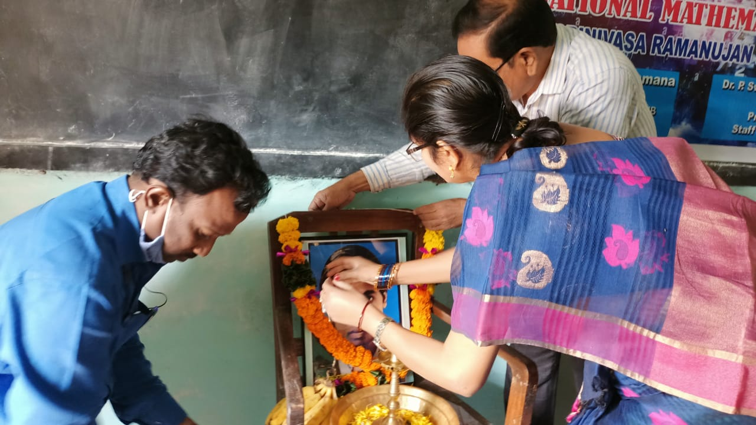
Chief Guest: Dr.P.Swapna Haindavee,Principal,GDCRajam
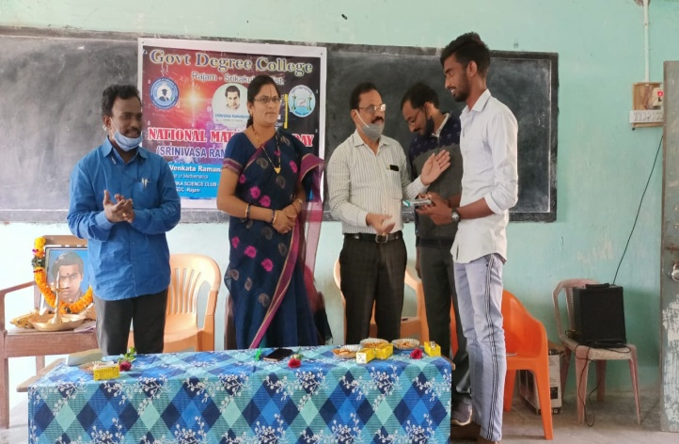
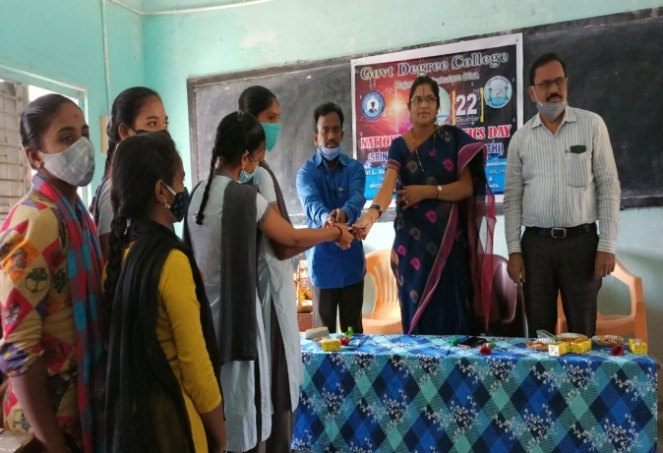
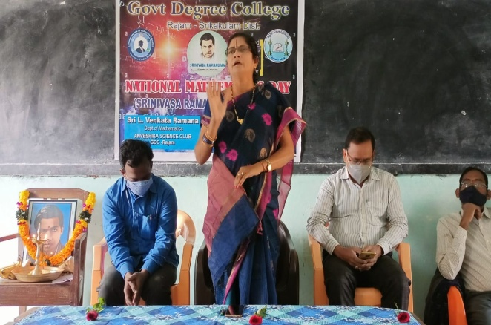

20.Conducted NATIONAL CONSUMERS DAY By Commerce Department on 24-12-2021
Chief Guest: Dr.P.Swapna Haindavee,Principal,GDCRajam
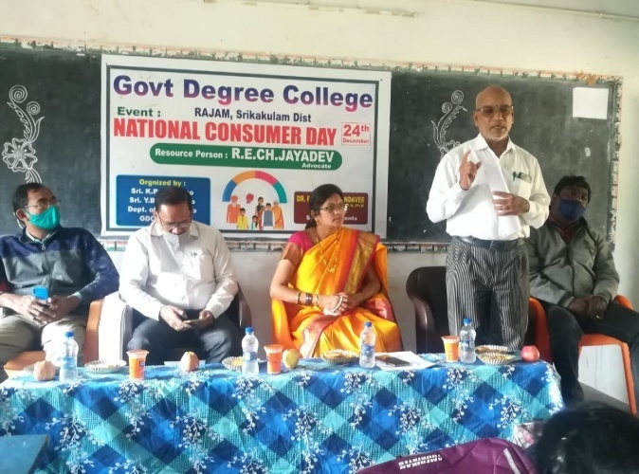
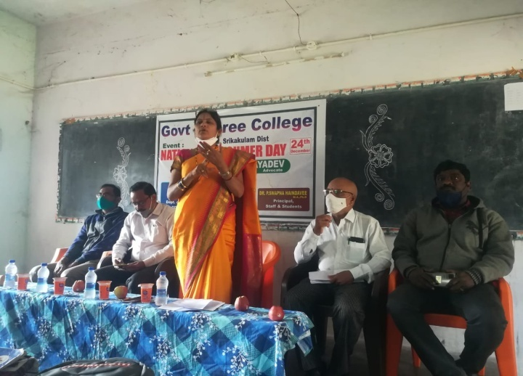
Chief Guest:Sri P.Jayaraju, Lawyer,Rajam
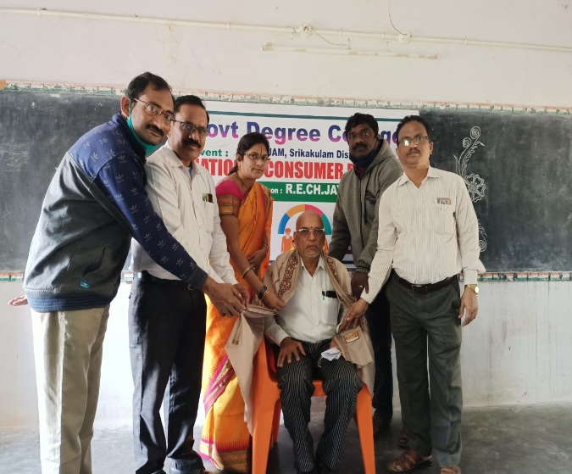
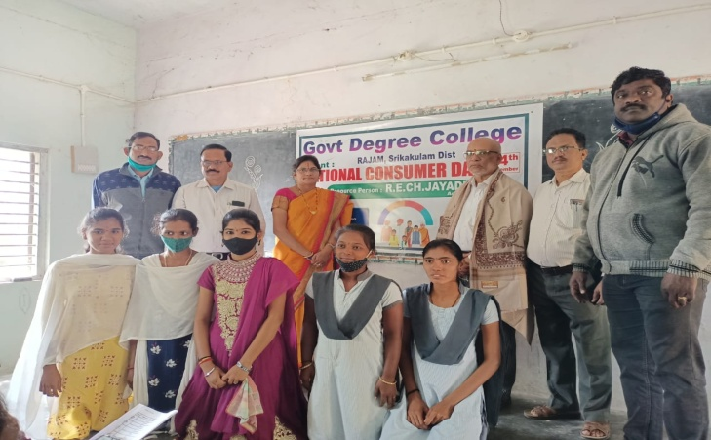
2022 ONWARDS
21.Conducted Smt.SAVITRIBAI PHULE JAYANTHI By Woman Empowerment Cell on 03-01-2022
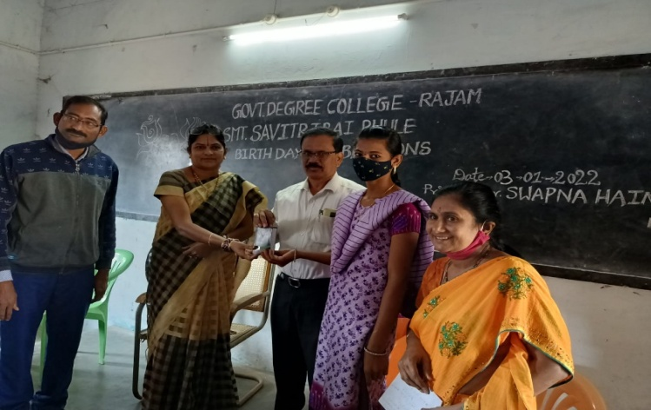
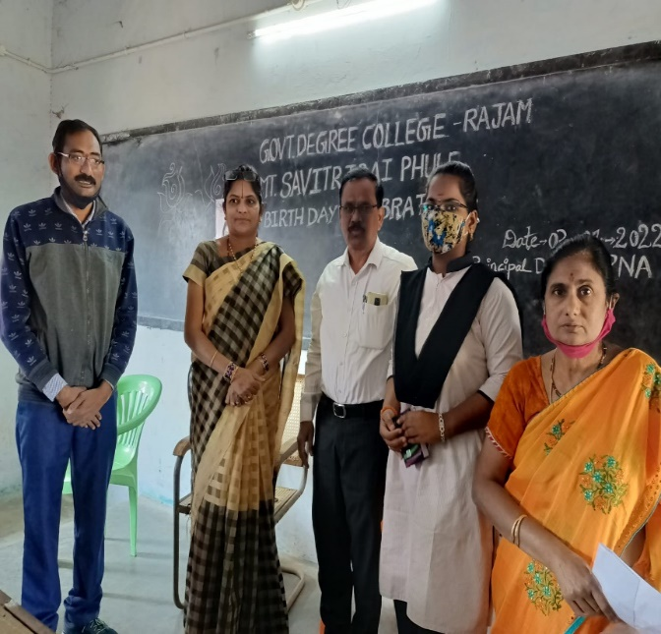
Chief Guest: Dr.P.Swapna Haindavee,Principal,GDCRajam
22.Conducted Awareness Rally on DISHA ACT with DSP Smt on 06-01-2022
Chief Guest: Dr.P.Swapna Haindavee,Principal,GDCRajam
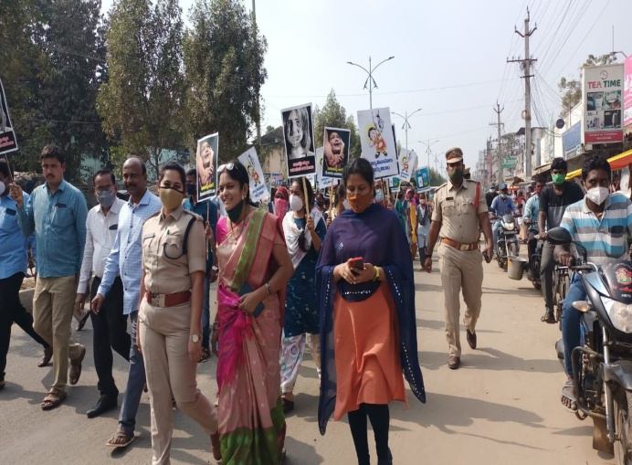
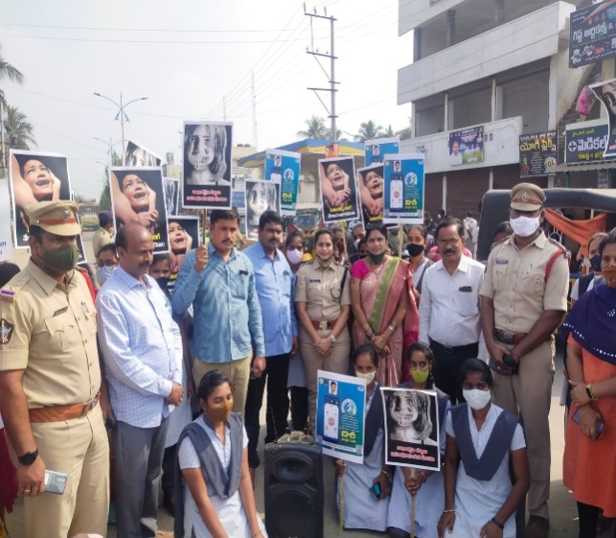

2323.Conducted Sankranthi Sambaralu on 07-01-2022
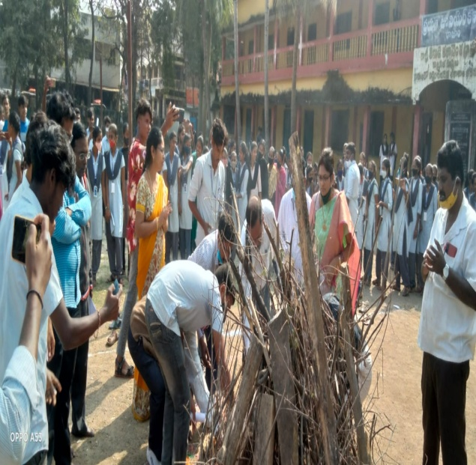
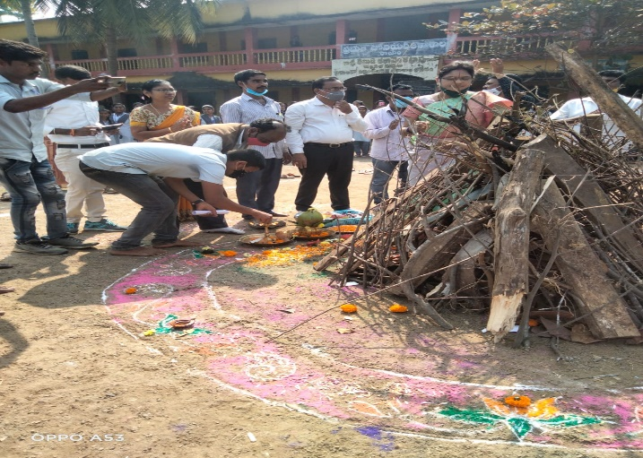
Chief Guest: Dr.P.Swapna Haindavee,Principal,GDCRajam
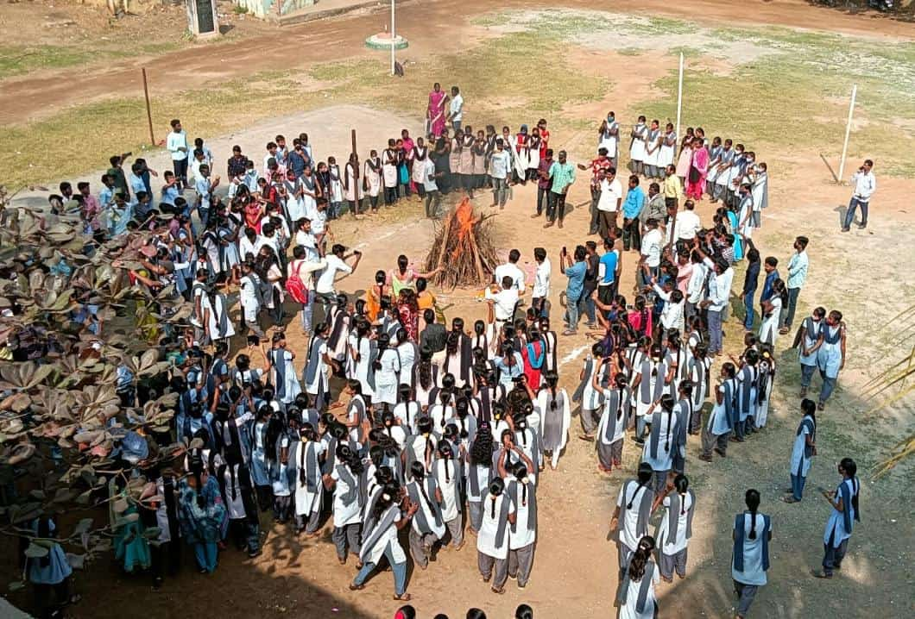
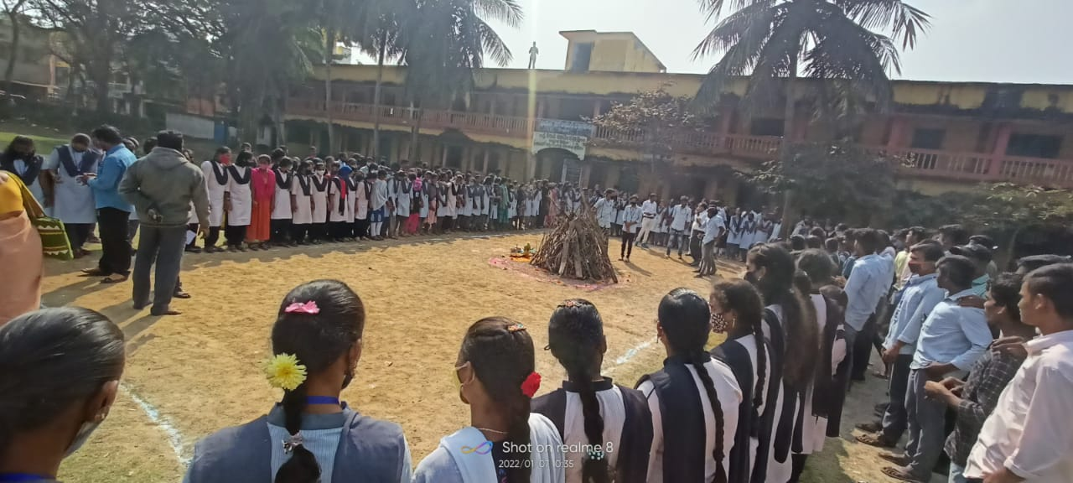
24.JAGANNA PACHCHA THORANAM CONSTRUCTION AND MAINTAINED BY PRAINCIPAL Dr.P.SWAPNA HAINDAVEE ON 23-01-2022
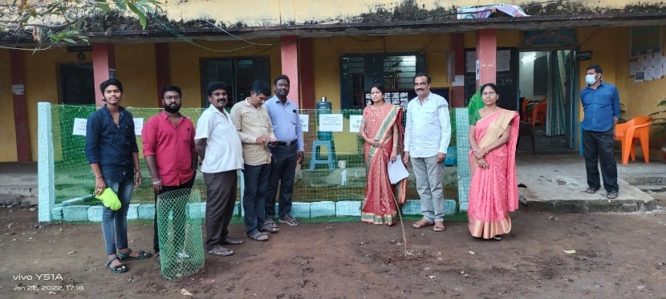
25.Conducted National Girl Child Education Day By Woman Empowerment Cell on 24-01-2022
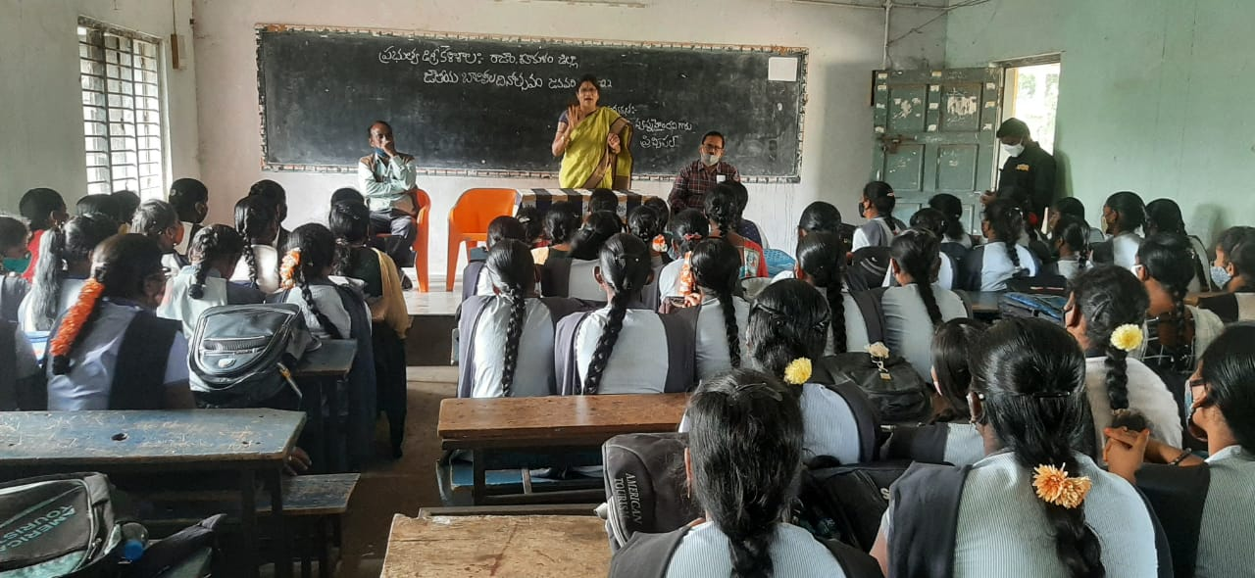
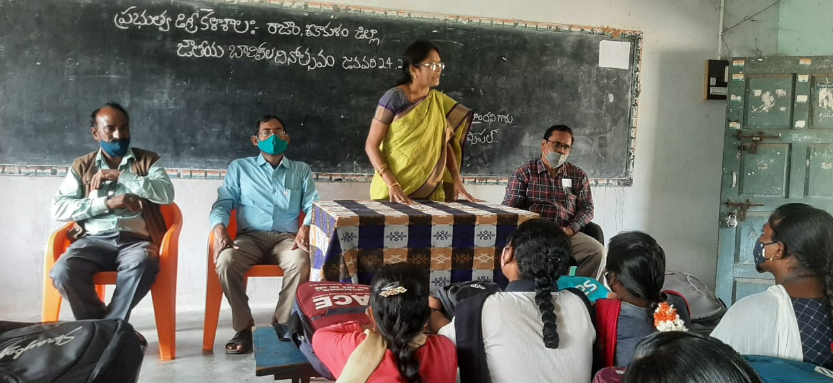
Chief Guest: Dr.P.Swapna Haindavee,Principal,GDCRajam
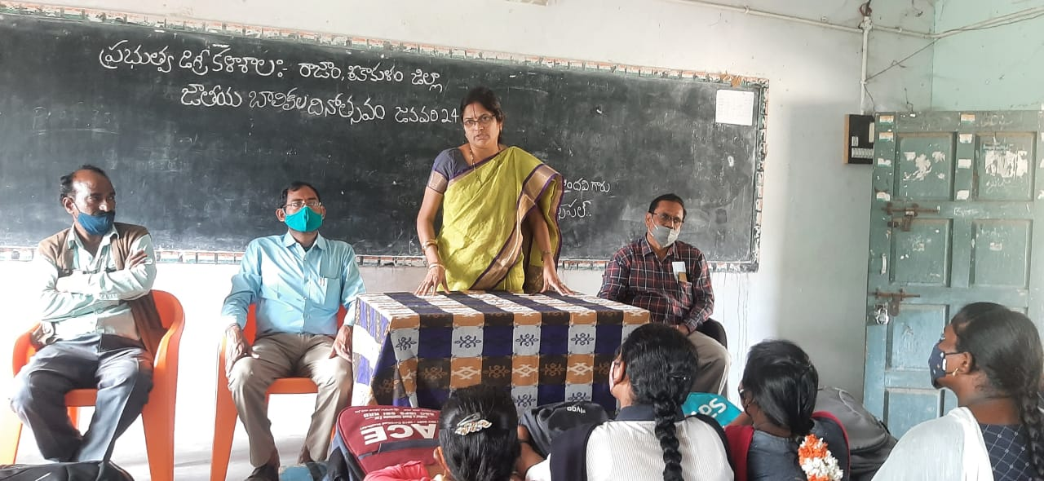
26.Conducted National Voters Day By Political Science Department on 25-01-2022
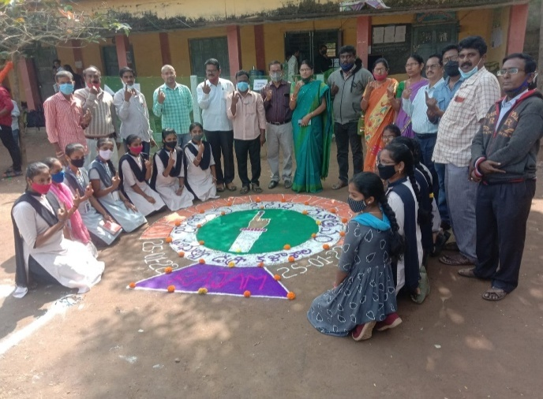
Chief Guest: Dr.P.Swapna Haindavee,Principal,GDCRajam
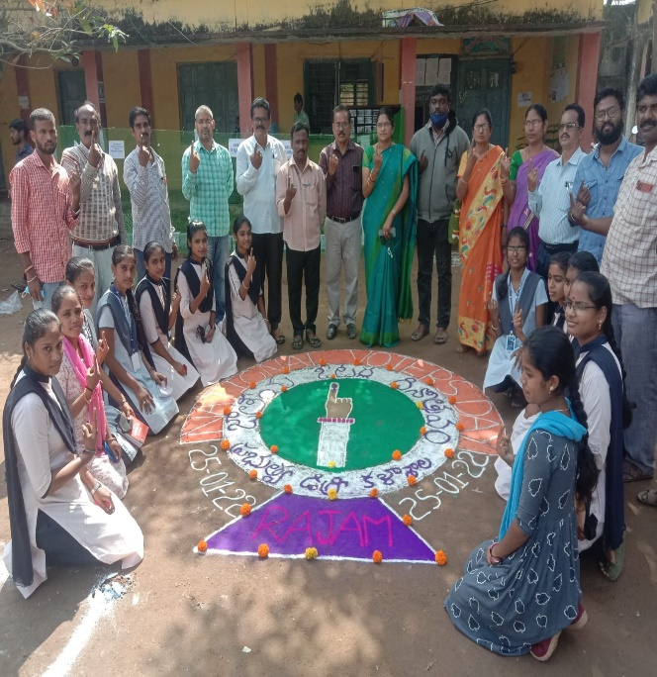

27.Conducted 73rdRepublic Day Celebrations Day on 26-01-2022
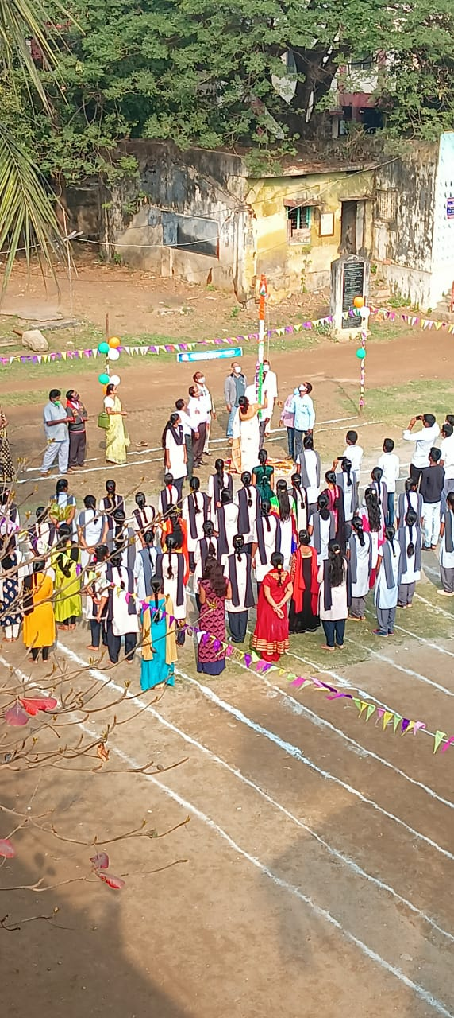
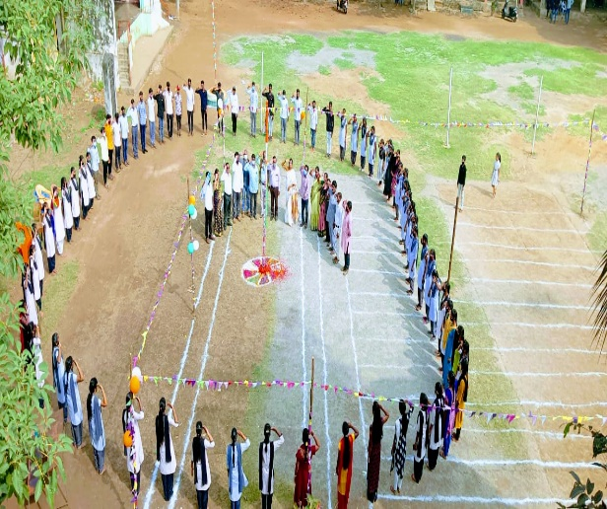
Chief Guest: Dr.P.Swapna Haindavee,Principal,GDCRajam

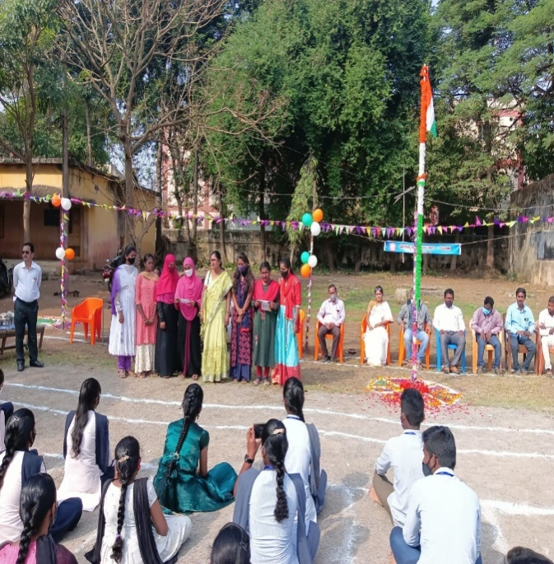
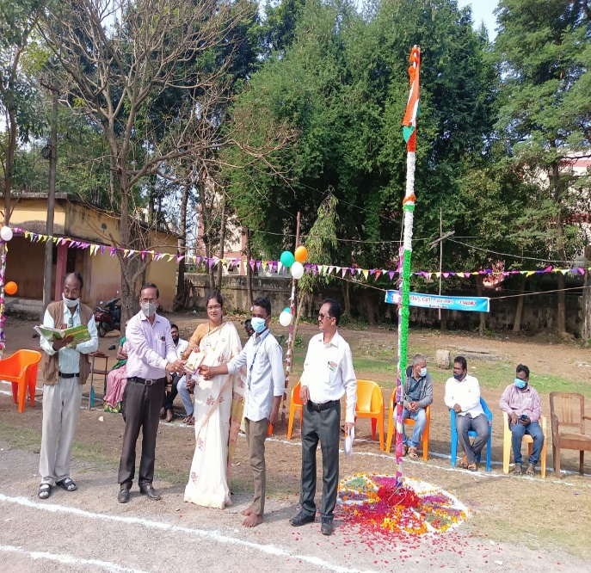
26.Conducted Motivational Class onSuicide Free India By the College with the Help of Spandana Eda International Foundation,Vizianagaram on 29-01-2022
Chief Guest: Dr.P.SwapnaHaindavee,Principal,GDCRajam
Motivation Trainer: Ramakrishna Garu
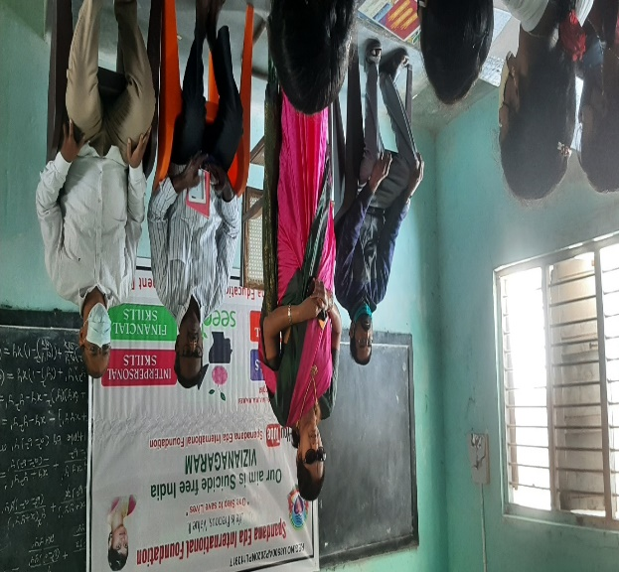
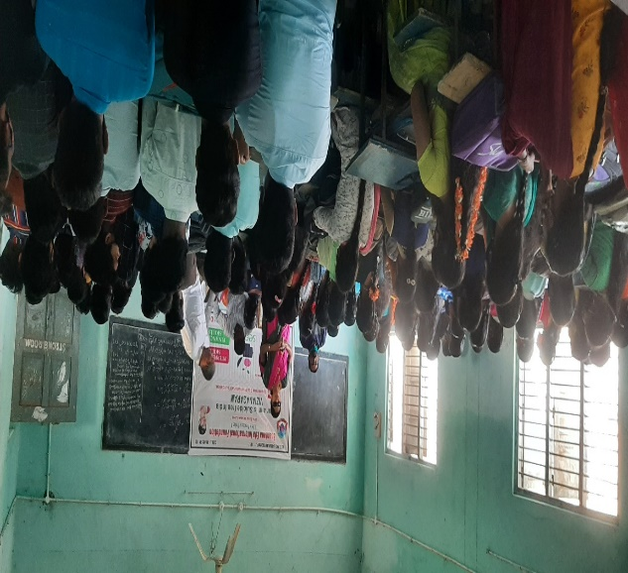
Spandana Eda International Foundation,Vizianagaram
